108 Cobequid Road, Suite 100  Lower Sackville, NS B4C 2N2 | www.opportunityplace.ca  902.864.7520
November 2019 Newsletter

Opportunity Place is a Nova Scotia Works Employment Service Centre. We are here to help you with career planning, job searching and on-the-job support at your convenience. Our team can introduce you to a variety of programs and services that will help you achieve your career goals. All of our services may be accessed in person, over the phone or through online applications. We also work with Nova Scotia’s employers to assist with recruitment, planning and Human Resources support.
Employment Support Services Offered at Opportunity Place

We are here to assist you with your employment plan!

- Identify Your Employment Needs  - Career Decision Making Assistance  - Job Search Workshops  - Self-Assisted Job Search Centre  & Computer Access  - Telephone Access for Job Search |  | - Learn About Workforce Trends  - Information on Training &  Self-Employment Options  - One-on-One Employment Support  - Referrals to Other Agencies
All services are free
We are here for you! Our hours of operation are
Monday to Friday 9:00 AM - 4:30 PM
Inside this Edition:
- November Workshop Calendar & Descriptions  - Find Us on Social Media  - Service Dog Notices  - Featured Workshops |  | - Canada Career Month Open House  - Career & Resource Fair  - Government of Nova Scotia Career Fair  - Opportunity Place Board of Directors Recruitment

 | November 2019 Workshop Schedule
 | Monday | Tuesday | Wednesday | Thursday | Friday
 |  |  |  |  | 1
 |  | Competitive Job Search  9:30 – 12:30  Transferable Skills  1:00 – 4:00 | Interviews 1  9:30 – 12:30  Interviews 2  1:00 – 4:00 | Self-Esteem  1:00 – 4:00
 | Remembrance  Day  Opportunity Place Closed | Social Media  9:30 – 12:30  SMART Goals  1:00 – 4:00 | Resumes 1  9:30 – 12:30  Resumes 2  1:00 – 4:00  Exploring  Self-Employment  1:00 – 4:00 | Resumes 3  9:30 – 12:30  Resumes 4  1:00 – 4:00  Disabilities in the  Workplace  1:00 – 4:00
 |  | 19 | 20 | 21 | 22
 | Career Planning 1  9:30 – 12:30  Career Planning 2  1:00 – 4:00  Job Fair Prep  1:00 – 4:00 | LMI General  9:30 – 12:30  LMI Specific  1:00 – 4:00  Stress Management  9:30 – 12:30 | Career Planning 3  9:30 – 12:30 | Interviews 1  9:30 – 12:30  Interviews 2  1:00 – 4:00  Managing Change  9:30 – 12:30
 | 25 | 26 | 27 | 28 | 29
 | Competitive Job Search  9:30 – 12:30  Transferable Skills  1:00 – 4:00 | Resumes 1  9:30 – 12:30  Resumes 2  1:00 – 4:00  How to Succeed in the  Workplace  9:30 – 12:30 | Resumes 3  9:30 – 12:30  Resumes 4  1:00 – 4:00 | Personality Dimensions  9:30 – 12:30  Confident Job Seeker  1:00 – 4:00
 | Follow us on social media for regular job postings and event notifications!

 | Workshop Descriptions
 | Career Planning (3-part workshop)  Develop a self-inventory by evaluating your skills, abilities, interests and work values. | Managing Change  Examine how change affects employability and develop strategies to cope with the challenges of being between jobs.
 | Competitive Job Search Strategies  Put yourself in an employer’s shoes and gain insight on how jobs are filled in today’s labour market. Find out about the hidden job market and how to get your foot in the right doors. | *New* Navigating Mental Health Resources  Want to learn more about mental health resources in the community? Come join our monthly orientation where we will explore mental health resources in HRM, as well as online resources. The purpose of this workshop is to provide an overview of services in the community with contact information. The orientation will include a hands-on demonstration on how to use the 2-1-1 website.
The Confident Job Seeker
Learn how to gain self-confidence that will create positive impacts in your life. Using discussions and exercises, learn the sources of low self-confidence and the steps to building self-confidence.
 | Disability in the Workplace  This workshop provides helpful tips for disclosing a disability, as well as requesting workplace accommodations. The rights and responsibilities of employees and employers are also discussed. | Personality Dimensions  Explore your own personality traits and how personalities might interact in the workplace. This information is useful in making informed career decisions and researching suitable working environments.
 | SMART Goals  A successful job search is more than knowing what you want to do, you need a plan on how you will get there. SMART goals put you on the path to success by creating clarity, focus and intention for reaching your ideal career. | Resumes for Results  Learn how to construct visually appealing and targeted resumes and cover letters that will get noticed by employers. Learn about formatting and how to market your skills.
 | Exploring Self-Employment as A Career Option  Have you ever thought of creating your own employment? This workshop will introduce you to the pros and cons of self-employment, as well as tools and resources. | Self-Esteem  Learn how to sell yourself and explore the process of building self-esteem. This workshop will help you to measure your self-esteem, and develop self-esteem boosters.
 | How to Succeed in the Workplace  Learn how to maintain employment and be successful in the workplace. Gain a better understanding of employer expectations and the qualities required to be a successful employee. | Social Media & Job Search  Learn the role of social media as a way to connect with companies and individuals. This workshop will provide an overview of how to use social media effectively in your job search to uncover potential job leads.
 | Interviews Part 1 & 2  Open, manage, and close an interview – learn appropriate responses to difficult interview questions. Learn how to respond with confidence to behavioral and situational interview questions. | Stress  What are the warning signs and impacts of stress? Assess how well you manage stress and learn ways to improve.
 | Labour Market Information (General & Specific)  Examine trends in the labour market to make informed decisions about your job search and employment path. | Transferable Skills  Identifying your transferable skills will help support your resume development, as well as define and expand your job search. Explore alternative work options related to your current skills.

Service Dog on Site
Please be advised that Opportunity Place has a service dog on site.
If being around a dog is any cause for concern, please let our staff know.
Opportunity Place is an inclusive space for staff and clients.
Featured Workshops

How to Succeed in the Workplace

If you have had difficulty keeping a job and want to ensure past experiences do not prevent you from moving towards your employment goals, this workshop is for you! Gain tips and insight that will help you maintain employment and achieve success in the workplace. This workshop will provide a better understanding of employer expectations and the qualities required to be a successful employee.
Discussions will include:
- What does it mean to be “job ready”?
- What are the key employability skills employers are looking for?
- How does workplace culture impact expectations?
- What are the most effective strategies for managing workplace conflict?
- What role does continuous learning play?

Learn effective strategies for managing and advancing your career while balancing job demands and personal expectations. Visit Opportunity Place today to register!
Exploring Self-Employment as a Career Option

Who hasn’t thought about being their own boss? The ability to do something that you love and get paid for it! Growing your own successful business is a dream many people have. Opportunity Place is offering an exciting new workshop that will explore self-employment.

“Exploring Self-Employment As A Career Option” will talk about several topics, such as:
• Pro’s and Con’s of Self Employment
• Steps in Exploring Self Employment
• Characteristics of an Entrepreneur
• Tools to Determine if You are Ready
• Self-Employment Tools and Resources

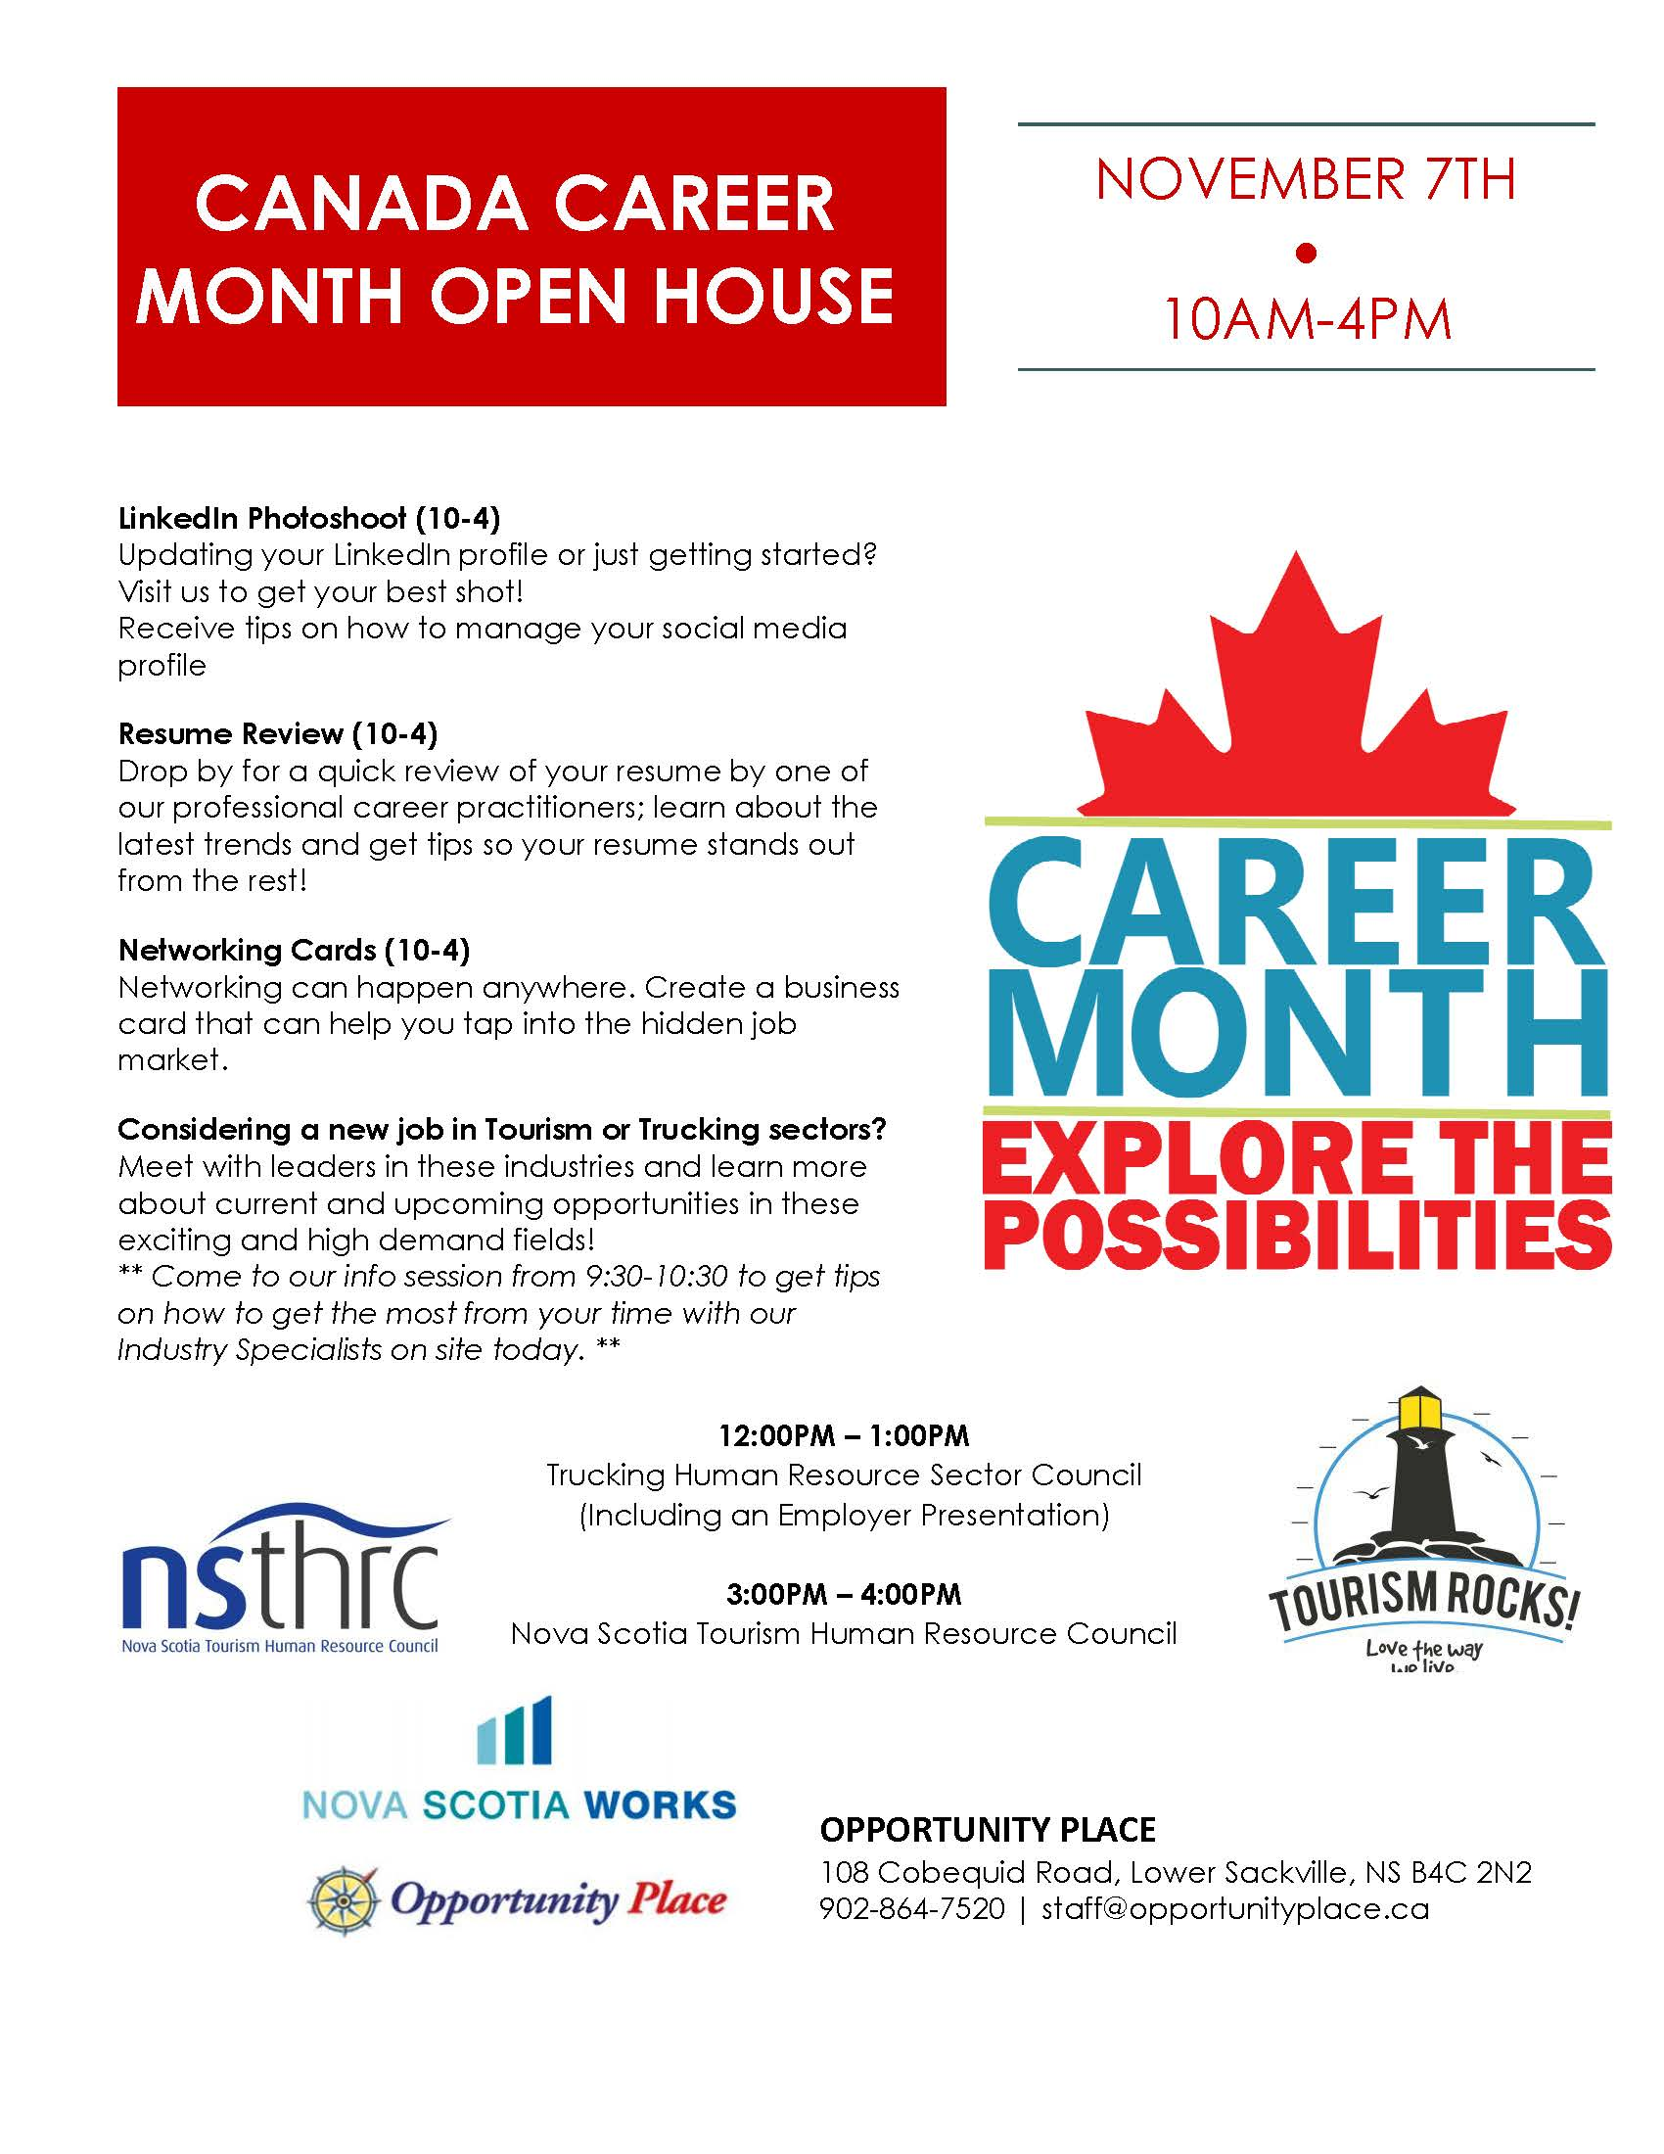

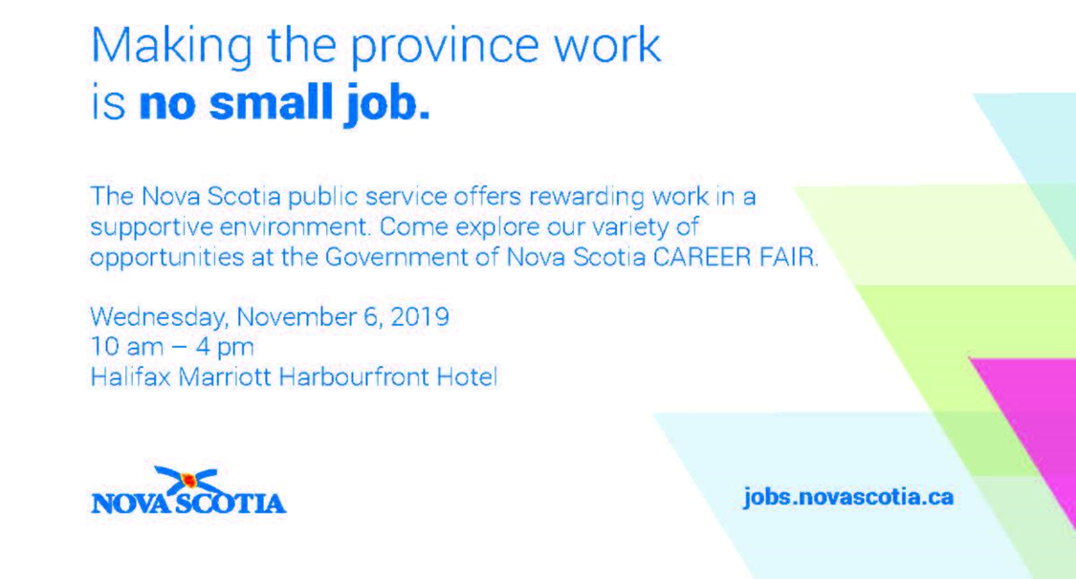

No Scents Makes Sense!
Perfume and scents can trigger asthma attacks, migraines, COPD, and MCS.
For the comfort and safety of all staff and clients, we appreciate your cooperation in keeping Opportunity Place a scent and fragrance-free environment.

Opportunity Place will be closed for Remembrance Day on
Monday, November 11^{th.}
Our office will re-open on Tuesday, November 12th for regular business hours.
Opportunity Place Board of Directors Recruitment
Opportunity Place Resource Association (OPRA) - the sponsor of Opportunity Place, a Nova Scotia Works Employment Services Centre - is actively seeking individuals who have the required abilities and commitment to serve on the Board of Directors.
​
Vision
To be the key provider of comprehensive career services for all stakeholders of Bedford/Sackville and surrounding area by ensuring the highest quality staff, programs, and community partnerships.

Core Values
Respect, Diversity, Collaboration, Flexibility, Growth, Energy, Encouragement
​
Objectives
- Opportunity Place Resource Association clients have the tools and resources and are appropriately prepared to become employed as part of a skilled workforce in the region.
- Opportunity Place Resource Association is a partner in a community known to be a driver and supporter of innovative solutions to employment, underemployment, and gaps in the labour market.
- Opportunity Place Resource Association is known as a community resource of excellence.

What does an OPRA Board Member need to have?
Potential volunteer board members require superior vision, leadership skills, and linkages with the community, and should share in the vision of OPRA. They should also bring solid skill sets (e.g. communications, financial, strategic planning, etc.) to benefit the organization as a whole. Finally, they should be prepared to work collaboratively with other board members, as well as all stakeholders.

What is in it for me?
As an OPRA board member, you would have the opportunity to further hone your skill set and gain valuable governance experience. You would have a part in creating the path the organization will take into the future. In short, besides the opportunity for significant individual personal growth, you will also be instrumental in the growth of our organization and its mandate within our area.

I am interested! What do I do now?
If the opportunity to serve on the OPRA Board of Directors interests you, we encourage you to visit our website www.opportunityplace.ca for more details.

Opportunity Place and TEAM Work
Nova Scotia Works Employment Service Centers
2120 Hammonds Plains Road
(MLA Ben Jessome’s Constituency Office)
Fridays 9:00 AM – 12:30 PM

As Nova Scotia Works Centers, Opportunity Place and TEAM Work Cooperative offer inclusive, diverse,
and accessible services to help job seekers and employers navigate a range of programs - from career
planning, job searches, and on-the-job support to recruitment, planning, and Human Resources support.

We are committed to increasing access for potential clients in the area of Hammonds Plains/Lucasville by
providing a community-based employment service and providing initial employment support as a
convenience for those who prefer local community-based services.

TEAM Work Cooperative or Opportunity Place will have an on-site Career Practitioner who will provide
assistance as required for clients as they identify needs.

General information on the services and programs offered through the NS Works Employment Service
Centres will be offered, as well as initial individual job and career conversations. We may offer compressed
mini café job search related workshops, one-on-one or small group sessions, résumé critiques, and
potentially women-centric services as needed. Broader services are available at the central locations in the
Halifax or Sackville areas.
Come visit us and let us help you succeed!
THANK YOU TO MLA BEN JESSOME FOR HIS GENEROUS SUPPORT!
The Opportunity Place (OPRA) Board of Directors is committed to respecting, fostering, and supporting diversity and inclusion at Opportunity Place within its leadership and governance.

Opportunity Place is sponsored by the Opportunity Place Resource Association (OPRA) -- a volunteer, not-for-profit association. OPRA believes that respect must be demonstrated by its leadership. Diverse and inclusive perspectives in decision making produce better decisions.

An organization which reflects the diversity of the many networks, groups, and communities within a framework of respect, equity, sensitivity, and competency in all aspects will be more effective in serving and working within those communities.

Opportunity Place is funded through the Canada-Nova Scotia Labour Market Development Agreement under the direction of Employment Nova Scotia.

